Remind for Parents

Hello parents!
- Do you want to see your child learning?
- Would you like to keep up to date on the fun events your child is part of at SKCDC (Southern Kennebec Child Development Corporation)?
- Would you like real time notifications of class changes?
Remind can help.
Remind is a secure, easy to use software platform that allows you and your child’s teachers to communicate directly. You can share pictures, videos, links, and messages at any time.

Creating an account
To complete this you will need
- A cell phone OR Desktop/laptop
- Your child’s class code – Your child’s teacher or the Center Supervisor can provide this to you.

From a Desktop/Laptop
Go to Remind.com and click sign up at the top right. You can sign up with your email address or phone number with an option later to add additional contact information if you choose.
An email or text will be sent with a confirmation code to confirm it is you.
Enter your name and a password
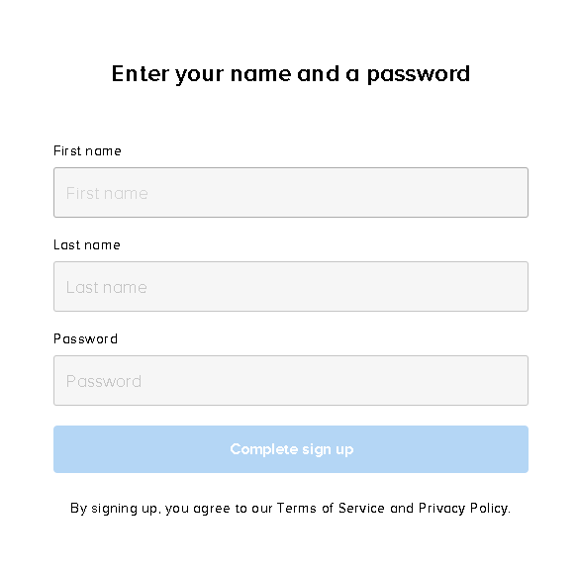
In the next section select that you are a PARENT
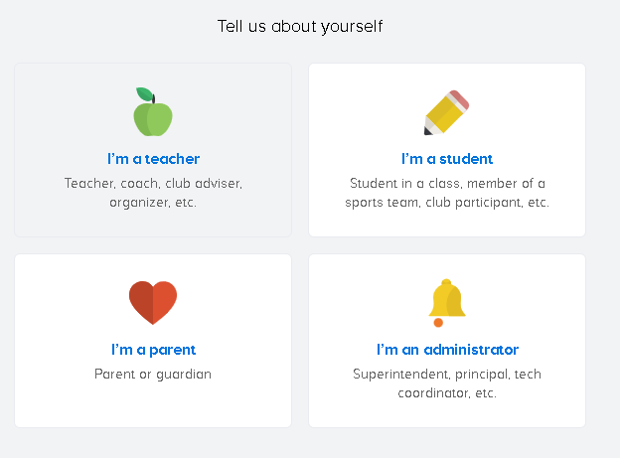

You can now enter a second way to contact, or you can skip this for now.
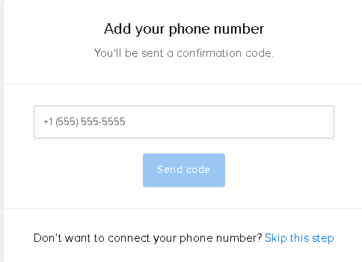
Finally, join your child’s class. Your child’s teacher likely provided this to you. It is a short code that starts with the @ symbol. Example: @myclass2
Note: Since the form already has the @ you will just need to enter the rest of the code.
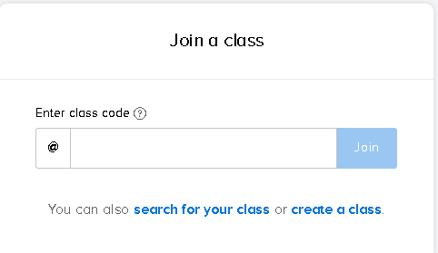

From a Cell phone
Open your web browser and go to rmd.at/myclass2 (do not use the @ symbol in the class name)
Follow the instructions to sign up for remind. You will be prompted to download the mobile app.

Joining the correct class
If you have not already joined a class when setting up your account or if your child moves classes and you need to join another class, use the Add Class -> Join Existing Class option.
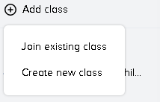

Navigating in Remind
You are now logged in and have joined your child’s class, what now?
When you select the class on the left menu, you will find several tabs that can be used.

Messages - Announcements
The messages tab allows you to review any announcements that have been made. If you would like to review announcements prior to joining the class, there is a link at the bottom

Files – Currently not used
We currently do not use this.

People - Corresponding with Teachers
Once you join a class you can then select the class and view the people tab. This tab will show a list of teachers and administrative staff that you can message and that can message you.
For your protection we only allow parents to communicate with staff via remind, parents are blocked from messaging other parents.

Calls – VoIP calling currently not used
We currently do not use this.

Information – Additional info about the class
Here you can view information about the class, its owners, and allows you to leave the class.

